Experiment 3.2
Determination and plotting of Force experienced by a charge with varying magnitude and distance

Code File Name: Exp3_2_ChargeForce_DifferentMagnitudes.m
Code
clc;
q1 = 5e-6;
q2 = 2e-6;
epsilon = 8.854e-12;
k = 1/(4*pi*epsilon);
r = linspace(0.5,5,100);
F = k*q1*q2./(r.^2);
plot(r,F,'LineWidth',2);
xlabel('Distance (m)');
ylabel('Force (N)');
title('Force between two charges (different magnitudes)');
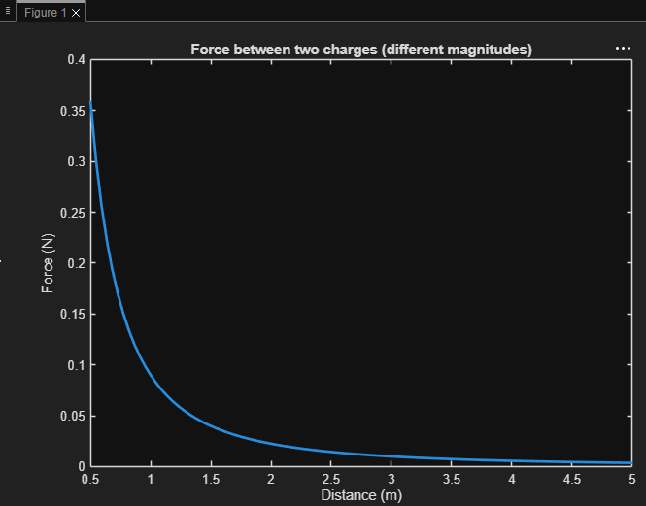
Output Graph

